MCA 2020-22 20MCA241 DATA SCIENCE LAB

# LAB CYCLE-1

**#1. Program to Print all non-Prime Numbers in an Interval. INPUT**

a **=** int(input("enter lower bound :"))

b **=** int(input("enter upper bound :"))

**for** n **in** range(a,b**+**1):

**if** n **>** 1:

**for** i **in** range(2,n):

**if** (n **%** i) **==** 0 :

print(n)

**break**

**OUTPUT**

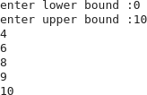

**#2. Program to print the first N Fibonacci numbers. INPUT**

n=int(input("enter the value of n : ")) a=0

b=1 sum=0 count=1

print("fibonacci series : ") while (count<=n): print(sum,end="") count+=1

a=b b=sum sum=a+b

**OUTPUT**



MCA 2020-22 20MCA241 DATA SCIENCE LAB

### #3. Program to find the roots of a quadratic equation(rounded to 2 decimal places). INPUT

**import** cmath

a**=**int(input("enter the value of a : ")) b**=**int(input("enter the value of b : ")) c**=**int(input("enter the value of c : "))

d**=**(b**\*\***2)**-**(4**\***a**\***c)

root1 **=** (**-**b**-**cmath**.**sqrt(d))**/**(2**\***a) root2 **=** (**-**b**+**cmath**.**sqrt(d))**/**(2**\***a)

print("{0} and {1} are the roots of a quadratic equation."**.**format(root1,root2))

**OUTPUT**

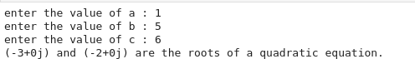

**#4. Program to check whether a given number is perfect number or not(sum of factors=number).**

**INPUT**

n**=**int(input("enter any value : ")) sum**=**0

**for** i **in** range(1,n):

**if** n **%** i **==** 0: sum**=**sum**+**i **if**(sum**==**n):

print(n,"is a perfect number.")

### else:

print(n,"is not a perfect number.")

**OUTPUT**



MCA 2020-22 20MCA241 DATA SCIENCE LAB

### #5. Program to display amstrong numbers upto 1000. INPUT

**for** n **in** range(0,1000):

sum**=**0 temp**=**n

**while** temp**>**0:

a**=**temp**%**10 sum**+=**a**\*\***3 temp**//=**10

**if** n**==**sum:

print(n)

**OUTPUT**



**#6. Write a program to perform bubble sort on a given set of elements.**

**INPUT**

l**=**[]

n**=**int(input("enter the no. elements :"))

**for** i **in** range(0,n): x**=**input() l**.**append(x)

print("before sorting elements")

**for** i **in** l: print(i,end**=**"")

**for** i **in** range(0,len(l)): **for** j **in** range(i**+**1,len(l)): **if** l[j]**<** l[i]:

temp**=**l[j] l[j]**=**l[i] l[i]**=**temp

MCA 2020-22 20MCA241 DATA SCIENCE LAB

print("\nafter bubble sort")

**for** i **in** l:

print(i,end**=**"")

**OUTPUT**

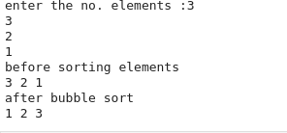

**#7. Write a Python program that accept a positive number and subtract from this number the sum of its digits and so on. Continues this operation until the number is positive.**

**INPUT**

**def** repeat_times(n):

s **=** 0

n_str **=** str(n)

**while** n **>** 0:

n **-=** sum([int(i) **for** i **in** list(n_str)]) n_str **=** list(str(n))

s **+=** 1

### return s

print(repeat_times(12)) print(repeat_times(9)) print(repeat_times(21))

**OUTPUT**

**#8. Write a Python program that accepts a 10 digit mobile number, and find the digits which are absent in a given mobile number.**

**INPUT**

**def** absent_digits(n):

all_nums **=** set([0,1,2,3,4,5,6,7,8,9])

MCA 2020-22 20MCA241 DATA SCIENCE LAB

n **=** set([int(i) **for** i **in** n])

n **=** n**.**symmetric_difference(all_nums) n **=** sorted(n)

**return** n print(absent_digits([9,8,3,2,2,0,9,7,6,3]))

**OUTPUT**



MCA 2020-22 20MCA241 DATA SCIENCE LAB

# LAB CYCLE-2

### #1. Create a 2 dimensional array (2X3) with elements belonging to complex datatype and print it. Also display

1. **the no: of rows and columns**

### dimension of an array

1. **reshape the same array to 3X2**

**INPUT**

import numpy as np

array_2d=np.array([[complex(1,2),complex(2,3),complex(3,4)],[complex(4,5),complex(5,6

),complex(6,7)]]) print(array_2d)

print("the no. of rows and columns :",array_2d.shape) print("dimension of an array",array_2d.ndim)

print("reshape the same array to 3x2",array_2d.reshape(3,2))

**OUTPUT**

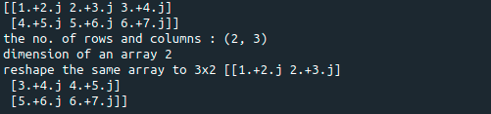

**#2. Create an one dimensional array using arange function containing 10 elements.**

### Display

1. **First 4 elements**

### Last 6 elements

1. **Elements from index 2 to 7**

MCA 2020-22 20MCA241 DATA SCIENCE LAB

**INPUT**

import numpy as np array_1d=np.array([1,2,3,4,5,6,7,8,9,10]) print("First 4 elements ",array_1d[:4]) print("Last 6 elements ",array_1d[4:])

print("Elements from index 2 to 7 ",array_1d[2:7])

**OUTPUT**

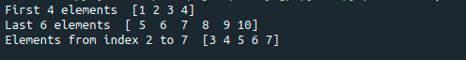

**#3. Create an 1D array with arange containing first 15 even numbers as elements**

### Elements from index 2 to 8 with step 2(also demonstrate the same using slice function)

1. **Last 3 elements of the array using negative index**

### Alternate elements of the array

1. **Display the last 3 alternate elements**

**INPUT**

import numpy as np

array_1d=np.array([0,2,4,6,8,10,12,14,16,18,20,22,24,26,28])

print("Elements from index 2 to 8 with step 2",array_1d[2:8:2]) print("Last 3 elements of the array using negative index",array_1d[-3:-1]) print("Alternate elements of the array",array_1d[::2])

print("Display the last 3 alternate elements",array_1d[-3:-1:2])

MCA 2020-22 20MCA241 DATA SCIENCE LAB

**OUTPUT**

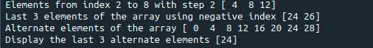

### #4. Create a 2 Dimensional array with 4 rows and 4 columns.

1. **Display all elements excluding the first row**

### Display all elements excluding the last column

1. **Display the elements of 1 st and 2 nd column in 2 nd and 3 rd row**

### Display the elements of 2 nd and 3 rd column

1. **Display 2 nd and 3 rd element of 1 st row**

### Display the elements from indices 4 to 10 in descending order(use–values)

**INPUT**

import numpy as np array_2d=np.array([[1,2,3,4],[5,6,7,8],[9,10,11,12],[13,14,15,16]])

print(array_2d)

print("Display all elements excluding the first row") print(array_2d[1:4,:])

print("Display all elements excluding the last column") print(array_2d[:,0:3])

print("Display the elements of 1 st and 2 nd column in 2 nd and 3 rd row") print(array_2d[1:3,1:3])

print("Display the elements of 2 nd and 3 rd column") print(array_2d[:,1:3])

print("Display 2 nd and 3 rd element of 1 st row") print(array_2d[0,1:3])

MCA 2020-22 20MCA241 DATA SCIENCE LAB

array=np.array([0,1,2,3,4,5,6,7,8,9,10])

print("Display the elements from indices 4 to 10 in descending order(use–values)") print(array[10:4:-1])

**OUTPUT**

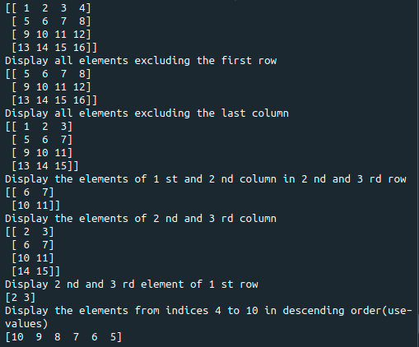

### #5.Create two 2D arrays using array object and

1. **Add the 2 matrices and print it**

### Subtract 2 matrices

1. **Multiply the individual elements of matrix**

### Divide the elements of the matrices

1. **Perform matrix multiplication**

### Display transpose of the matrix

1. **Sum of diagonal elements of a matrix**

MCA 2020-22 20MCA241 DATA SCIENCE LAB

**INPUT**

import numpy as np

x=np.array([[1,2],[3,4]])

y=np.array([[5,6],[7,8]]) print("Add the 2 matrices") print(np.add(x,y)) print("Subtract 2 matrices") print(np.subtract(x,y))

print("Multiply the individual elements of matrix") print(np.multiply(x,y))

print("Divide the elements of the matrices") print(np.divide(x,y))

print("Perform matrix multiplication") print(np.dot(x,y))

print("Display transpose of the matrix") print(x.transpose())

print(y.transpose())

print("Sum of diagonal elements of a matrix") print(np.trace(x))

print(np.trace(y))

MCA 2020-22 20MCA241 DATA SCIENCE LAB

**OUTPUT**

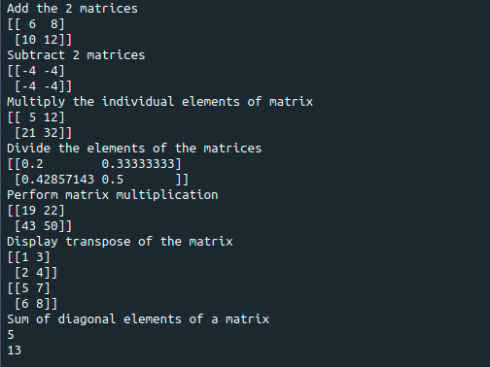

**#6. Create a square matrix with random integer values(use randint()) and use appropriate functions to find:**

### inverse

1. **rank of matrix**

### Determinant

1. **transform matrix into 1D array**

### eigen values and vectors.

**INPUT**

import numpy as np matrix=np.random.randint(0,10,4).reshape(2,2) print(matrix)

inverse=np.linalg.inv(matrix)

MCA 2020-22 20MCA241 DATA SCIENCE LAB

print("inverse of matrix") print(inverse) rank=np.linalg.matrix_rank(matrix) print("rank of matrix",rank) det=np.linalg.det(matrix) print("Determinant of matrix",det) array_1d=matrix.flatten() print("transform matrix into 1D array") print(array_1d) eigen=np.linalg.eig(matrix) print("eigen values and vectors") print(eigen)

**OUTPUT**

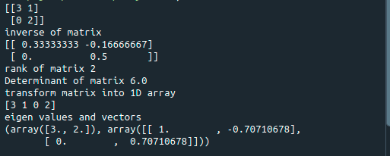

**#7. Create a matrix X with suitable rows and columns**

### Display the cube of each element of the matrix using different methods (use multiply(), *, power(),**)

1. **Display identity matrix of the given square matrix.**

### Display each element of the matrix to different powers.

1. **Create a matrix Y with same dimension as X and perform the operation X 2 +2Y**

MCA 2020-22 20MCA241 DATA SCIENCE LAB

import numpy as np matrix=np.random.randint(0,10,4).reshape(2,2)

print("Display the cube of each element of the matrix using different methods (use multiply(), *, power(),**)")

x=np.power(matrix,3) print("power()",x) y=np.multiply(matrix,(matrix*matrix)) print("multiply()")

print(y) z=matrix*matrix*matrix print("**")

print(z) cube=matrix*3 print("*") print(cube)

print("Display identity matrix of the given square matrix.") identity=np.identity(2,dtype=int)

print(identity)

print("Display each element of the matrix to different powers.") dpow=np.power(matrix,matrix)

print(dpow)

print("Create a matrix Y with same dimension as X and perform the operation X^2 +2Y")

a=np.add((np.power(x,2)),(np.multiply(y,2))) print(a)

MCA 2020-22 20MCA241 DATA SCIENCE LAB

**OUTPUT**

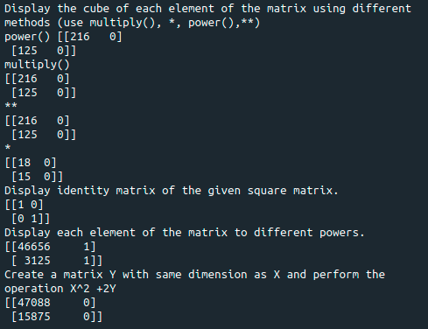

### #8. Write a program to find out the value of X using solve(), given A and b. INPUT

import numpy as np A=np.array([[2, 1, -2],

[3, 0, 1],

[1, 1, -1]])

b=np.array([[3],

[5],

[-2]])

inv=np.linalg.inv(A) x=np.linalg.solve(inv,b) print(x)

MCA 2020-22 20MCA241 DATA SCIENCE LAB

**OUTPUT**

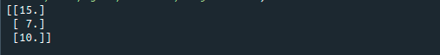

**#9. Write a program to perform the SVD of a given matrix. Also reconstruct the given matrix from the 3 matrices obtained after performing SVD.**

**INPUT**

from numpy import array from numpy import diag from numpy import dot from numpy import zeros from scipy.linalg import svd

A = array([[1, 2], [3, 4], [5, 6]])

print(A)

U, s, VT = svd(A) print(U)

print(s) print(VT)

Sigma = zeros((A.shape[0], A.shape[1]))

Sigma[:A.shape[1], :A.shape[1]] = diag(s) B = U.dot(Sigma.dot(VT))

print(B)

**OUTPUT**

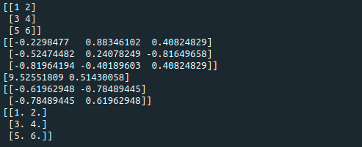

MCA 2020-22 20MCA241 DATA SCIENCE LAB

# LAB CYCLE-3

### #1. Sarah bought a new car in 2001 for $24,000. The dollar value of her car changed each year as shown in the table below.

**Value of Sarah&#39;s Car**

|  |  |
| --- | --- |
| **Year** | **Value** |
| **2001** | **$24,000** |
| **2002** | **$22,500** |
| **2003** | **$19,700** |
| **2004** | **$17,500** |
| **2005** | **$14,500** |
| **2006** | **$10,000** |
| **2007** | **$10,000** |

### Represent the following information using a line graph with following style properties X- axis - Year

**Y –axis - Car Value**

### title –Value Depreciation (left Aligned)

**Line Style dashdot and Line-color should be red point using * symbol with green color and size 20 Subplot() provides multiple plots in one figure.**

**INPUT**

import matplotlib.pyplot as plt import numpy as np

x = np.array([2001,2002,2003,2004,2005,2006,2007])

y= np.array([24000,22500,19700,17500,14500,10000,10000])

print("x-axis=> Year y-axis=> Car Value")

plt.plot(x,y, ls = '-.',color = 'r',marker= '*', ms='20', mfc='green', mec='green')

MCA 2020-22 20MCA241 DATA SCIENCE LAB

plt.title("Value Depreciation", loc='left') plt.xlabel("Year")

plt.ylabel("Car Value") plt.show()

**OUTPUT**

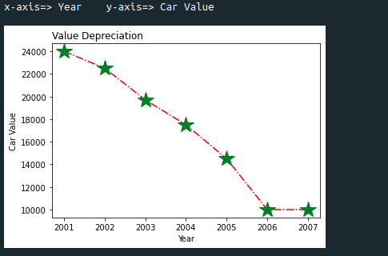

**#2. Use subplot function to draw the line graphs with grids(color as blue and line style dotted) for the above information as 2 separate graphs in two rows**

### Properties for the Graph 1:

**X label- Days of week Y label-Sale of Drinks**

### Title-Sales Data1 (right aligned) Line –dotted with cyan color

**Points- hexagon shape with color magenta and outline black**

### Properties for the Graph 2:

MCA 2020-22 20MCA241 DATA SCIENCE LAB

### X label- Days of Week Y label-Sale of Food

**Title-Sales Data2 ( center aligned) Line –dashed with yellow color**

### Points- diamond shape with color green and outline red

**INPUT**

import matplotlib.pyplot as plt import numpy as np

x= np.array(['Mon','Tues','Wed','Thurs','Fri']) y= np.array([300,450,150,400,650])

plt.subplot(1, 2, 1) plt.title("Sales Data1") plt.xlabel("Days of Week") plt.ylabel("Sale of Drinks") plt.plot(x, y, ':c')

plt.plot(x, y, 'Hm',mec='k')

plt.grid(color="blue", ls=':')

c= np.array(['Mon','Tues','Wed','Thurs','Fri']) v= np.array([400,500,350,300,500])

plt.subplot(1, 2, 2) plt.title("Sales Data2") plt.xlabel("Days of week") plt.ylabel("Sales of Food") plt.plot(c,v, '--y')

plt.plot(c,v, 'Dg',mec='r')

plt.grid(color='blue', ls=':') plt.show()

MCA 2020-22 20MCA241 DATA SCIENCE LAB

**OUTPUT**

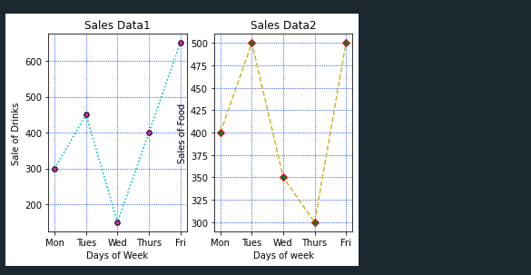

**#3. Create scatter plot for the below data: (use Scatter function)**

### Create scatter plot for each Segment with following properties within one graph X Label- Months of Year with font size 18

**Y-Label- Sales of Segments Title –Sales Data**

### Color for Affordable segment- pink Color for Luxury Segment- Yellow Color for Super luxury segment-blue

**INPUT**

import matplotlib.pyplot as plt import numpy as np

plt.title('Sales Data') plt.xlabel('Months of Year')

MCA 2020-22 20MCA241 DATA SCIENCE LAB

plt.ylabel('Sale of Food')

x = np.array([173,153,195,147,120,144,148,109,174,130,172,131]) y = np.array([173,153,195,147,120,144,148,109,174,130,172,131])

plt.scatter(x,y, color='hotpink')

x = np.array([185,185,126,134,196,153,112,133,200,145,167,110]) y = np.array([185,185,126,134,196,153,112,133,200,145,167,110])

plt.scatter(x, y, color='yellow')

x = np.array([189,189,105,112,173,109,151,197,174,145,177,161]) y = np.array([189,189,105,112,173,109,151,197,174,145,177,161])

plt.scatter(x, y, color='blue') plt.show()

**OUTPUT**

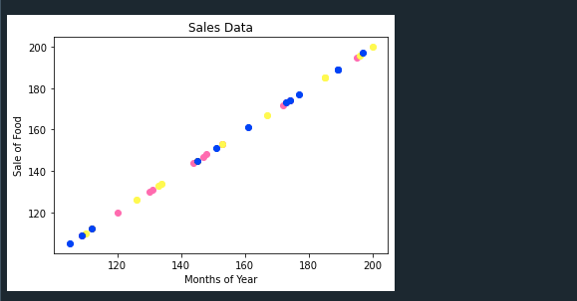

MCA 2020-22 20MCA241 DATA SCIENCE LAB

### #4. Display the above data using multiline plot( 3 different lines in same graph) Display the description of the graph in upper right corner(use legend())

**Use different colors and line styles for 3 different lines**

**INPUT**

import matplotlib.pyplot as plt import numpy as np

x = [1,2,3,4,5]

y = [3,3,3,3,3]

z = [4,4,4,4,4]

plt.plot(x, y, label='line 1') plt.plot(y, x, label='line 2') plt.plot(z, x, label='line 3') plt.legend()

plt.show()

**OUTPUT**

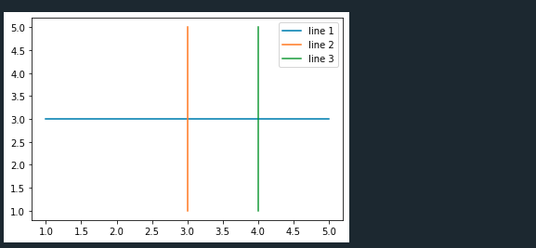

MCA 2020-22 20MCA241 DATA SCIENCE LAB

### #5. 100 students were asked what their primary mode of transport for getting to school was. The results of this survey are recorded in the table below. Construct a bar graph representing this information.

**Create a bar graph with**

### X axis -mode of Transport and Y axis ‘frequency’ Provide appropriate labels and title

**Width .1, color green**

**INPUT**

import matplotlib.pyplot as plt import numpy as np plt.title('Students transportation') plt.xlabel('Mode of Transport') plt.ylabel('Frequency')

x = np.array(['Walking','Cycling','Car','Bus','Train']) y = np.array([29,15,35,18,3])

plt.bar(x, y, color="#4CAF50",width = 0.1) plt.show()

**OUTPUT**

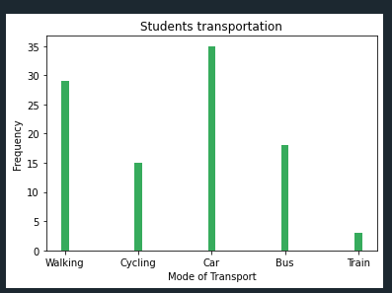

MCA 2020-22 20MCA241 DATA SCIENCE LAB

### #6. We are provided with the height of 30 cherry trees.

**The height of the trees (in inches): 61, 63, 64, 66, 68, 69, 71, 71.5, 72, 72.5, 73, 73.5, 74,**

### 74.5, 76, 76.2,76.5, 77, 77.5, 78, 78.5, 79, 79.2, 80, 81, 82, 83, 84, 85, 87.

**Create a histogram with a bin size of 5**

**INPUT**

import matplotlib.pyplot as plt

height =

[61,63,64,66,68,69,71,71.5,72,72.5,73,73.5,74,74.5,76,76.2,76.5,77,77.5,78,78.5,79,79.2,8

0,81,82,83,84,85,87]

plt.hist(height, edgecolor='red', bins=5) plt.show()

**OUTPUT**

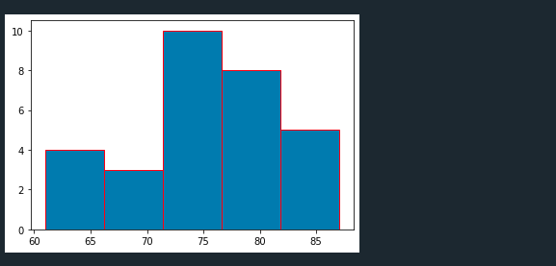

MCA 2020-22 20MCA241 DATA SCIENCE LAB

**DATA HANDLING USING ‘Pandas’ and DATA VISUALIZATION USING**

**‘Seaborn’**

### #7. Using the pandas function read_csv(), read the given ‘iris’ data set.

**INPUT**

**import** numpy **as** np

**import** matplotlib.pyplot **as** plt

**import** seaborn **as** sns

**import** pandas **as** pd

col **=** ['sepal_length','sepal_width','petal_length','petal_width','type'] iris**=**pd**.**read_csv("iris.csv",names**=**col)

### Shape of the data set.

print("shape :",iris**.**shape) shape : (151, 5)

### First 5 and last five rows of data set(head and tail).

print("first five rows") print(iris**.**head()) print("***************") print("last five rows") print(iris**.**tail())

MCA 2020-22 20MCA241 DATA SCIENCE LAB

**OUTPUT**

first five rows

sepal_length sepal_width petal_length petal_width type

0 sepal.length sepal.width petal.length petal.width variety 1 5.1 3.5 1.4 .2 Setosa 2 4.9 3 1.4 .2 Setosa 3 4.7 3.2 1.3 .2 Setosa 4 4.6 3.1 1.5 .2 Setosa

*************** last five rows

sepal_length sepal_width petal_length petal_width type

146 6.7 3 5.2 2.3 Virginica

147 6.3 2.5 5 1.9 Virginica

148 6.5 3 5.2 2 Virginica 149 6.2 3.4 5.4 2.3 Virginica

150 5.9 3 5.1 1.8 Virginica

### Size of dataset.

print("size :",iris.size)

**OUTPUT**

size : 755

### No. of samples available for each variety.

print("no. of samples available for each type") print(iris["type"]**.**value_counts())

MCA 2020-22 20MCA241 DATA SCIENCE LAB

**OUTPUT**

no. of samples available for each type Setosa 50

Versicolor 50

Virginica 50

variety 1

Name: type, dtype: int64

### Description of the data set( use describe ).

print("description of the data set") print(iris**.**describe())

**OUTPUT**

description of the data set

|  |  |  |  |  |  |
| --- | --- | --- | --- | --- | --- |
|  | sepal_length | sepal_width | petal_length | petal_width | type |
| count | 151 | 151 | 151 | 151 | 151 |
| unique | 36 | 24 | 44 | 23 | 4 |
| top | 5 | 3 | 1.5 | .2 | Setosa |
| freq | 10 | 26 | 13 | 29 | 50 |

matplotlib inline

### #8. Use pairplot() function to display pairwise relationships between attributes. Try different kind of plots {‘scatter’, ‘kde’, ‘hist’, ‘reg’} and different kind of markers.

**INPUT**

iris **=** sns**.**load_dataset("iris") sns**.**pairplot(iris)

MCA 2020-22 20MCA241 DATA SCIENCE LAB

**OUTPUT**

<seaborn.axisgrid.PairGrid at 0x7f5620ec8520>

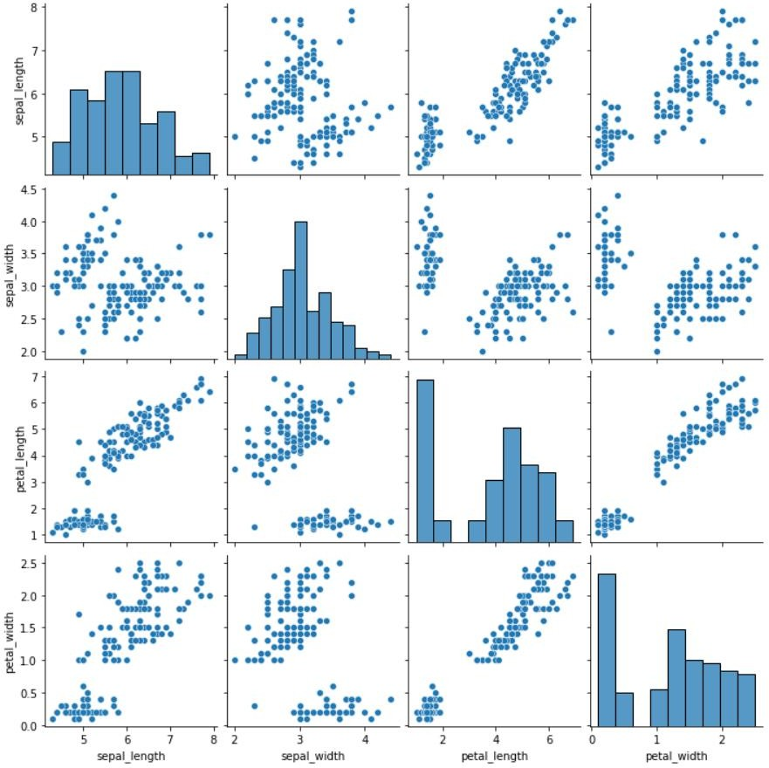

sns**.**pairplot(iris, hue**=**"species", kind**=**"kde")

MCA 2020-22 20MCA241 DATA SCIENCE LAB

**OUTPUT**

<seaborn.axisgrid.PairGrid at 0x7f5607971910>

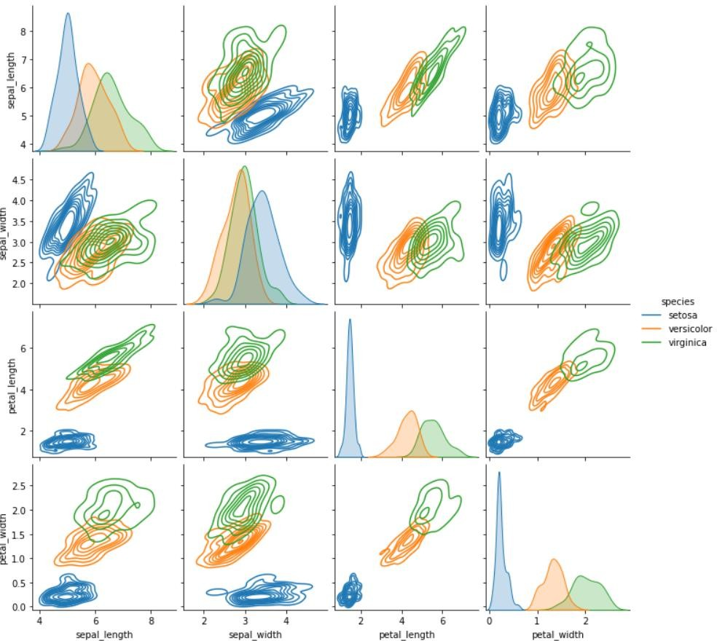

sns**.**pairplot(iris, hue**=**"species", kind**=**"hist")

MCA 2020-22 20MCA241 DATA SCIENCE LAB

**OUTPUT**

<seaborn.axisgrid.PairGrid at 0x7f5606015850>

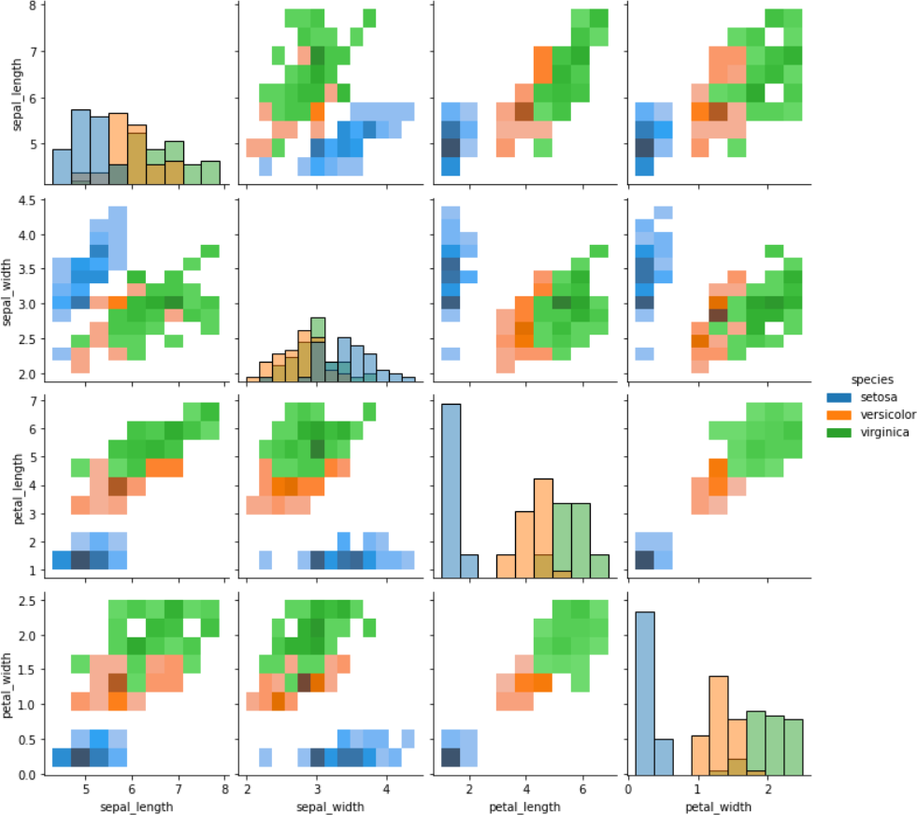

sns**.**pairplot(iris, hue**=**"species", kind**=**"reg")

MCA 2020-22 20MCA241 DATA SCIENCE LAB

**OUTPUT**

<seaborn.axisgrid.PairGrid at 0x7f56067c9be0>

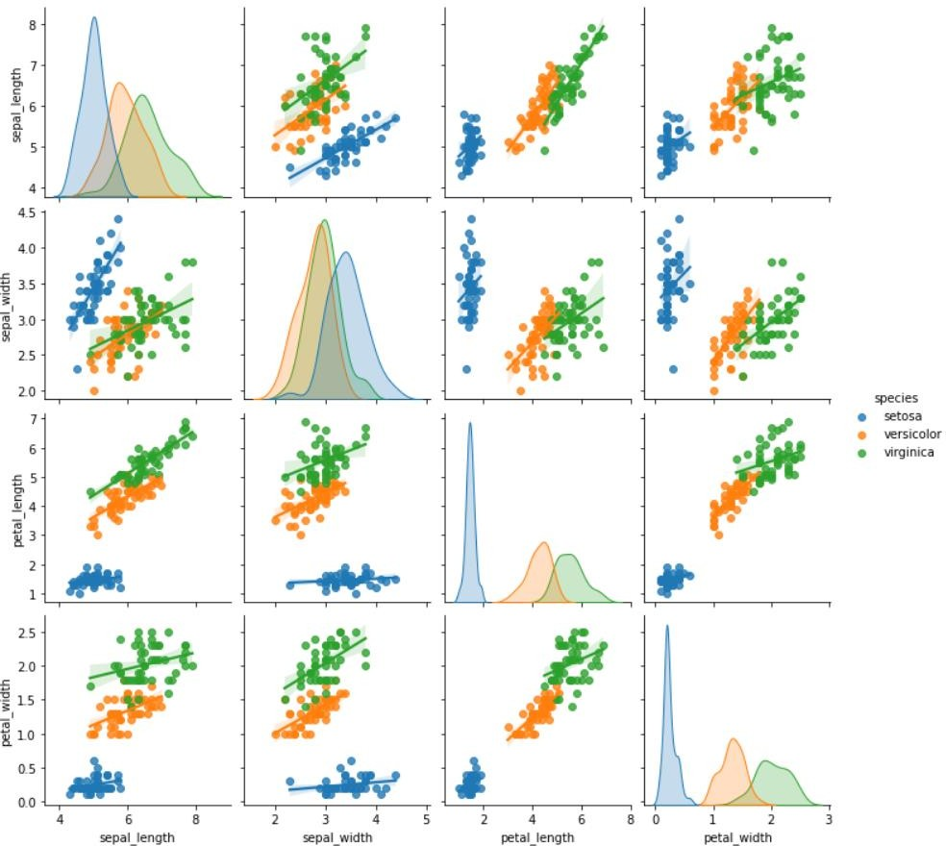

sns**.**pairplot(iris, hue**=**"species", kind**=**"scatter")

MCA 2020-22 20MCA241 DATA SCIENCE LAB

**OUTPUT**

<seaborn.axisgrid.PairGrid at 0x7f56079710d0>

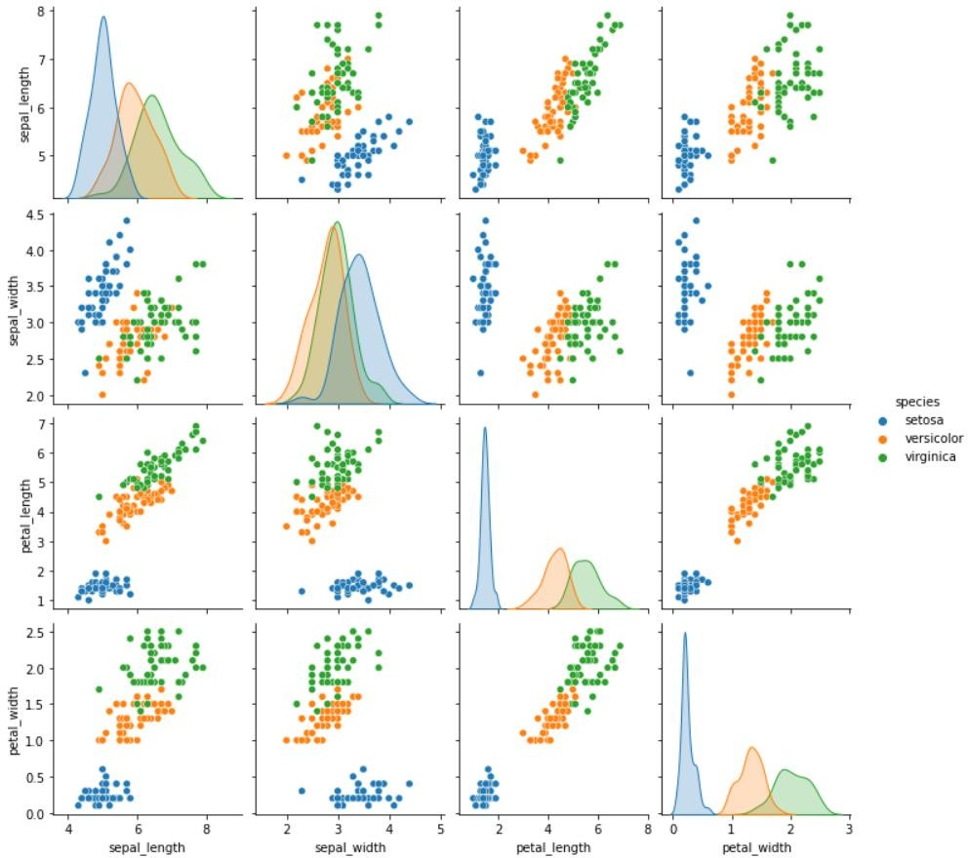

### #9. Using the iris data set,get familiarize with functions:

* 1. **displot()**

### histplot()

* 1. **relplot()**

MCA 2020-22 20MCA241 DATA SCIENCE LAB

**INPUT**

plt**.**style**.**use("dark_background") sns**.**displot(iris**.**sepal_length, bins**=**20, color**=**"g")

plt**.**title("Distribution of sepal_length", fontsize**=**20, color **=** 'red') plt**.**show()

**OUTPUT**

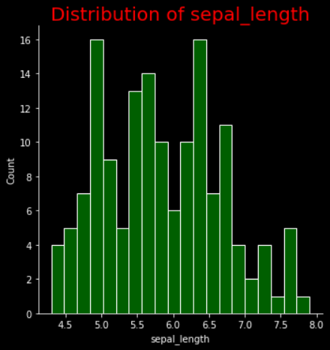

sns**.**histplot(iris**.**sepal_width, bins**=**20, color**=**"g") plt**.**title("Distribution of sepal_width", fontsize**=**20, color **=** 'red') plt**.**show()

MCA 2020-22 20MCA241 DATA SCIENCE LAB

**OUTPUT**

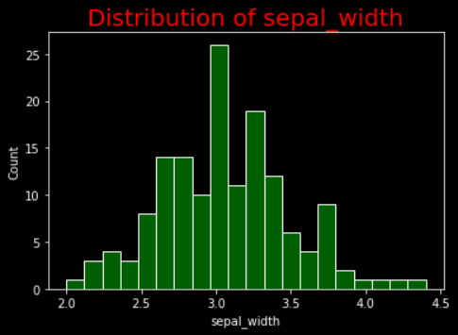

sns**.**relplot(data**=**iris,kind**=**"line")

**OUTPUT**

<seaborn.axisgrid.FacetGrid at 0x7f560452f430>

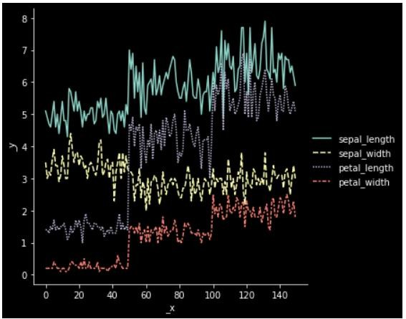

sns**.**displot(iris)

MCA 2020-22 20MCA241 DATA SCIENCE LAB

**OUTPUT**

<seaborn.axisgrid.FacetGrid at 0x7f56043dc550>

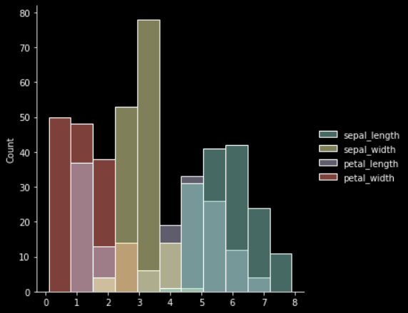

sns**.**histplot(iris)

**OUTPUT**

<AxesSubplot:ylabel='Count'>

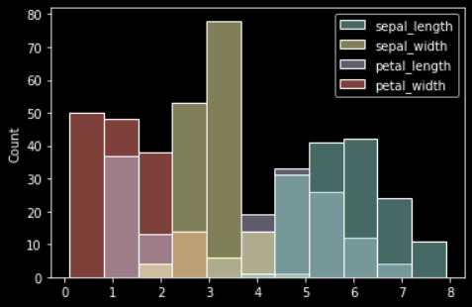

MCA 2020-22 20MCA241 DATA SCIENCE LAB

# LAB CYCLE-4

## KNN Algorithm

### #1. Using the iris data set implement the KNN algorithm. Take different values for Test and training data set .Also use different values for k. Also find the accuracy level.

**INPUT**

**import** numpy **as** np

**import** matplotlib.pyplot **as** plt

**import** pandas **as** pd

dataset **=** pd**.**read_csv("iris.csv")

X **=** dataset**.**iloc[:, :**-**1]**.**values y **=** dataset**.**iloc[:, 4]**.**values

**from** sklearn.model_selection **import** train_test_split

X_train, X_test, y_train, y_test **=** train_test_split(X, y, test_size**=**0.20)

**from** sklearn.neighbors **import** KNeighborsClassifier classifier **=** KNeighborsClassifier(n_neighbors**=**5) classifier**.**fit(X_train, y_train)

y_pred **=** classifier**.**predict(X_test)

**from** sklearn.metrics **import** classification_report, confusion_matrix print(classification_report(y_test, y_pred))

|  |  |  |  |  |  |
| --- | --- | --- | --- | --- | --- |
| MCA 2020-22 |  |  |  | 20MCA241 | DATA SCIENCE LAB |
| **OUTPUT** |  |  |  |  |  |
| precision | recall | f1-score | support |  |  |
| Setosa |  | 1.00 | 1.00 | 1.00 | 13 |
| Versicolor |  | 1.00 | 1.00 | 1.00 | 10 |
| Virginica |  | 1.00 | 1.00 | 1.00 | 7 |
| accuracy |  |  |  | 1.00 | 30 |
| macro avg |  | 1.00 | 1.00 | 1.00 | 30 |
| weighted avg |  | 1.00 | 1.00 | 1.00 | 30 |
| **from** sklearn.metrics **import** accuracy_score  print ("Accuracy : ", accuracy_score(y_test, y_pred))  df **=** pd**.**DataFrame({'Real Values':y_test, 'Predicted Values':y_pred})  **OUTPUT**  Accuracy : 0.9333333333333333  **#2. Download another data set suitable for the KNN and implement the KNN algorithm.Take different values for Test and training data set .Also use different values for k.**  **INPUT**  **import** numpy **as** np  **import** matplotlib.pyplot **as** plt  **import** pandas **as** pd  dataset **=** pd**.**read_csv("cancer.csv") | | | | | |

MCA 2020-22 20MCA241 DATA SCIENCE LAB

dataset**.**head() dataset**.**info()

X **=** dataset**.**iloc[:, 2:35]**.**values print(X)

y **=** dataset**.**iloc[:, 1]**.**values print(y)

**OUTPUT**

<class 'pandas.core.frame.DataFrame'> RangeIndex: 568 entries, 0 to 567 Data columns (total 32 columns):

# Column Non-Null Count Dtype

|  |  |  |  |  |
| --- | --- | --- | --- | --- |
| 0 | 842302 | 568 | non-null | int64 |
| 1 | M | 568 | non-null | object |
| 2 | 17.99 | 568 | non-null | float64 |
| 3 | 10.38 | 568 | non-null | float64 |
| 4 | 122.8 | 568 | non-null | float64 |
| 5  . . | 1001  . | 568 | non-null | float64 |
| 31 | 0.1189 | 568 | non-null | float64 |

dtypes: float64(30), int64(1), object(1) memory usage: 142.1+ KB

[[2.057e+01 1.777e+01 1.329e+02 ... 1.860e-01 2.750e-01 8.902e-02] [1.969e+01 2.125e+01 1.300e+02 ... 2.430e-01 3.613e-01 8.758e-02] [1.142e+01 2.038e+01 7.758e+01 ... 2.575e-01 6.638e-01 1.730e-01]

MCA 2020-22 20MCA241 DATA SCIENCE LAB

...

[1.660e+01 2.808e+01 1.083e+02 ... 1.418e-01 2.218e-01 7.820e-02] [2.060e+01 2.933e+01 1.401e+02 ... 2.650e-01 4.087e-01 1.240e-01] [7.760e+00 2.454e+01 4.792e+01 ... 0.000e+00 2.871e-01 7.039e-

02]]

['M' 'M' 'M' 'M' 'M' 'M' 'M' 'M' 'M' 'M' 'M' 'M' 'M' 'M' 'M' 'M' 'M' 'M'

'B' 'B' 'B' 'M' 'M' 'M' 'M' 'M' 'M' 'M' 'M' 'M' 'M' 'M' 'M' 'M' 'M' 'M'

'B' 'M' 'M' 'M' 'M' 'M' 'M' 'M' 'M' 'B' 'M' 'B' 'B' 'B' 'B' 'B' 'M' 'M'

'B' 'M' 'M' 'B' 'B' 'B' 'B' 'M' 'B' 'M' 'M' 'B' 'B' 'B' 'B' 'M' 'B' 'M'

**INPUT**

**from** sklearn.model_selection **import** train_test_split

X_train, X_test, y_train, y_test **=** train_test_split(X, y, test_size**=**0.20)

**from** sklearn.neighbors **import** KNeighborsClassifier classifier **=** KNeighborsClassifier(n_neighbors**=**5) classifier**.**fit(X_train, y_train)

y_pred **=** classifier**.**predict(X_test)

**from** sklearn.metrics **import** classification_report, confusion_matrix print(classification_report(y_test, y_pred))

MCA 2020-22 20MCA241 DATA SCIENCE LAB

**OUTPUT**

precision recall f1-score support

|  |  |  |  |  |
| --- | --- | --- | --- | --- |
| B | 0.93 | 0.97 | 0.95 | 78 |
| M | 0.94 | 0.83 | 0.88 | 36 |
| accuracy |  |  | 0.93 | 114 |
| macro avg | 0.93 | 0.90 | 0.92 | 114 |
| weighted avg | 0.93 | 0.93 | 0.93 | 114 |

**from** sklearn.metrics **import** accuracy_score

print ("Accuracy : ", accuracy_score(y_test, y_pred))

df **=** pd**.**DataFrame({'Real Values':y_test, 'Predicted Values':y_pred})

**OUTPUT**

Accuracy : 0.9298245614035088

## Naive Bayes Classification Algorithm

### #3. Using iris data set, implement naive bayes classification for different naive Bayes classification algorithms.( (i) gaussian (ii) bernoulli etc)

* **Find out the accuracy level w.r.t to each algorithm**

### Display the no:of mislabeled classification from test data set

* **List out the class labels of the mismatching records**

**import** numpy **as** np

**import** matplotlib.pyplot **as** plt

MCA 2020-22 20MCA241 DATA SCIENCE LAB

**import** pandas **as** pd

dataset **=** pd**.**read_csv('iris.csv')

X **=** dataset**.**iloc[:,:4]**.**values y **=** dataset['variety']**.**values dataset**.**head(5)

**OUTPUT**

|  |  |  |  |  |  |
| --- | --- | --- | --- | --- | --- |
| **sepal.length** | | **sepal.width** | **petal.length** | **petal.width** | **variety** |
| **0** | 5.1 | 3.5 | 1.4 | 0.2 | Setosa |
| **1** | 4.9 | 3.0 | 1.4 | 0.2 | Setosa |
| **2** | 4.7 | 3.2 | 1.3 | 0.2 | Setosa |
| **3** | 4.6 | 3.1 | 1.5 | 0.2 | Setosa |
| **4** | 5.0 | 3.6 | 1.4 | 0.2 | Setosa |
| **INPUT** |  |  |  |  |  |

**from** sklearn.model_selection **import** train_test_split

X_train, X_test, y_train, y_test **=** train_test_split(X, y, test_size **=** 0.2)

**from** sklearn.naive_bayes **import** GaussianNB classifier **=** GaussianNB() classifier**.**fit(X_train, y_train)

MCA 2020-22 20MCA241 DATA SCIENCE LAB

y_pred **=** classifier**.**predict(X_test) y_pred

**OUTPUT**

array(['Setosa', 'Versicolor', 'Versicolor', 'Versicolor', 'Setosa',

'Virginica', 'Versicolor', 'Versicolor', 'Virginica', 'Virginica',

'Setosa', 'Setosa', 'Setosa', 'Versicolor', 'Virginica', 'Versicolor', 'Versicolor', 'Setosa', 'Versicolor',

'Setosa',

'Setosa', 'Virginica', 'Setosa', 'Versicolor', 'Versicolor',

'Virginica', 'Versicolor', 'Virginica', 'Setosa', 'Versicolor'],

dtype='<U10')

**INPUT**

**from** sklearn.metrics **import** confusion_matrix cm **=** confusion_matrix(y_test, y_pred)

**from** sklearn.metrics **import** accuracy_score

print ("Accuracy : ", accuracy_score(y_test, y_pred)) cm

**OUTPUT**

Accuracy : 0.9333333333333333

|  |  |  |
| --- | --- | --- |
| array([[10, | 0, | 0], |
| [ 0, | 11, | 0], |
| [ 0, | 2, | 7]]) |

MCA 2020-22 20MCA241 DATA SCIENCE LAB

**INPUT**

df **=** pd**.**DataFrame({'Real Values':y_test, 'Predicted Values':y_pred}) df

**OUTPUT**

|  |  |  |
| --- | --- | --- |
|  | **Real Values** | **Predicted Values** |
| **0** | Setosa | Setosa |
| **1** | Versicolor | Versicolor |
| **2** | Versicolor | Versicolor |
| **3** | Versicolor | Versicolor |
| **4** | Setosa | Setosa |
| **5** | Virginica | Virginica |
| **6** | Virginica | Versicolor |
| **7** | Versicolor | Versicolor |
| **8** | Virginica | Virginica |
| **9** | Virginica | Virginica |
| **10** | Setosa | Setosa |
| **11** | Setosa | Setosa |
| **12** | Setosa | Setosa |
| **13** | Versicolor | Versicolor |

MCA 2020-22 20MCA241 DATA SCIENCE LAB

|  |  |  |
| --- | --- | --- |
|  | **Real Values** | **Predicted Values** |
| **14** | Virginica | Virginica |
| **15** | Versicolor | Versicolor |
| **16** | Versicolor | Versicolor |
| **17** | Setosa | Setosa |
| **18** | Virginica | Versicolor |
| **19** | Setosa | Setosa |
| **20** | Setosa | Setosa |
| **21** | Virginica | Virginica |
| **22** | Setosa | Setosa |
| **23** | Versicolor | Versicolor |
| **24** | Versicolor | Versicolor |
| **25** | Virginica | Virginica |
| **26** | Versicolor | Versicolor |
| **27** | Virginica | Virginica |
| **28** | Setosa | Setosa |
| **29** | Versicolor | Versicolor |

MCA 2020-22 20MCA241 DATA SCIENCE LAB

|  |  |
| --- | --- |
| **Real Values** | **Predicted Values** |

## Decision Tree Algorithm

### #4. Use car details CSV file and implement decision tree algorithm

* **Find out the accuracy level.**

### Display the no: of mislabelled classification from test data set

* **List out the class labels of the mismatching records INPUT**

**import** os

**import** numpy **as** np

**import** pandas **as** pd

**import** numpy **as** np**,** pandas **as** pd

**import** matplotlib.pyplot **as** plt

**from** sklearn **import** tree, metrics, model_selection

data **=**

pd**.**read_csv('car.csv',names**=**['buying','maint','doors','persons','lug_boot','safety','class']) data**.**head()

MCA 2020-22 20MCA241 DATA SCIENCE LAB

**OUTPUT**

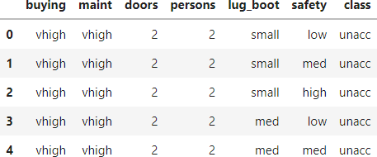

data**.**info()

**OUTPUT**

<class 'pandas.core.frame.DataFrame'> RangeIndex: 1728 entries, 0 to 1727 Data columns (total 7 columns):

# Column Non-Null Count Dtype

1. buying 1728 non-null object
2. maint 1728 non-null object
3. doors 1728 non-null object
4. persons 1728 non-null object
5. lug_boot 1728 non-null object
6. safety 1728 non-null object
7. class 1728 non-null object dtypes: object(7)

memory usage: 94.6+ KB

**INPUT**

data['class'],class_names **=** pd**.**factorize(data['class'])

print(class_names) print(data['class']**.**unique())

MCA 2020-22 20MCA241 DATA SCIENCE LAB

**OUTPUT**

Index(['unacc', 'acc', 'vgood', 'good'], dtype='object') [0 1 2 3]

**INPUT**

data['buying'],_ **=** pd**.**factorize(data['buying']) data['maint'],_ **=** pd**.**factorize(data['maint']) data['doors'],_ **=** pd**.**factorize(data['doors']) data['persons'],_ **=** pd**.**factorize(data['persons']) data['lug_boot'],_ **=** pd**.**factorize(data['lug_boot']) data['safety'],_ **=** pd**.**factorize(data['safety']) data**.**head()

**OUTPUT**

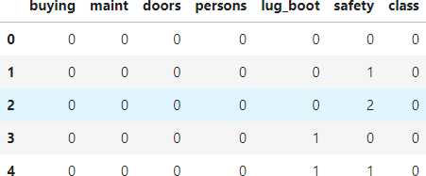

data**.**info()

**OUTPUT**

<class 'pandas.core.frame.DataFrame'> RangeIndex: 1728 entries, 0 to 1727

MCA 2020-22 20MCA241 DATA SCIENCE LAB

Data columns (total 7 columns):

# Column Non-Null Count Dtype

1. buying 1728 non-null int64
2. maint 1728 non-null int64
3. doors 1728 non-null int64
4. persons 1728 non-null int64
5. lug_boot 1728 non-null int64
6. safety 1728 non-null int64
7. class 1728 non-null int64 dtypes: int64(7)

memory usage: 94.6 KB

**INPUT**

X **=** data**.**iloc[:,:**-**1]

y **=** data**.**iloc[:,**-**1]

X_train, X_test, y_train, y_test **=** model_selection**.**train_test_split(X, y, test_size**=**0.3, random_state**=**0)

dtree **=** tree**.**DecisionTreeClassifier(criterion**=**'entropy', max_depth**=**3, random_state**=**0) dtree**.**fit(X_train, y_train)

**OUTPUT**

DecisionTreeClassifier(criterion='entropy', max_depth=3, random_state=0)

**INPUT**

y_pred **=** dtree**.**predict(X_test)

accuracy **=** metrics**.**accuracy_score(y_test, y_pred) print('Accuracy: {:.2f}'**.**format(accuracy))

MCA 2020-22 20MCA241 DATA SCIENCE LAB

**OUTPUT**

Accuracy: 0.82

**INPUT**

count_misclassified **=** (y_test **!=** y_pred)**.**sum() print('Misclassified samples: {}'**.**format(count_misclassified))

**OUTPUT**

Misclassified samples: 96

## Simple Linear Regression

### #5. Implement Simple and multiple linear regression for the data sets ‘student_score.csv’ and ‘company_data .csv’ respectively.

**INPUT**

**import** numpy **as** np

**import** pandas **as** pd

**import** matplotlib.pyplot **as** plt

student **=** pd**.**read_csv('student_scores.csv') student**.**head()

MCA 2020-22 20MCA241 DATA SCIENCE LAB

**OUTPUT**

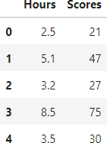

**INPUT**

student**.**describe()

**OUTPUT**

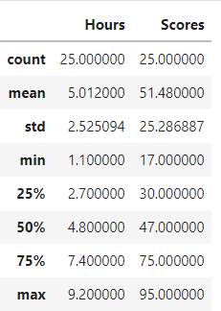

student**.**info()

**OUTPUT**

<class 'pandas.core.frame.DataFrame'> RangeIndex: 25 entries, 0 to 24

|  |  |  |
| --- | --- | --- |
| MCA 2020-22 |  | 20MCA241 DATA SCIENCE LAB |
| Data | columns | (total 2 columns): |
| # | Column | Non-Null Count Dtype |
| 0 | Hours | 25 non-null float64 |
| 1 | Scores | 25 non-null int64 |

dtypes: float64(1), int64(1) memory usage: 528.0 bytes

**INPUT**

**import** matplotlib.pyplot **as** plt Xax**=**student**.**iloc[:,0] Yax**=**student**.**iloc[:,1] plt**.**scatter(Xax,Yax) plt**.**xlabel("No.of hours") plt**.**ylabel("Score") plt**.**title("Student scores") plt**.**show()

**OUTPUT**

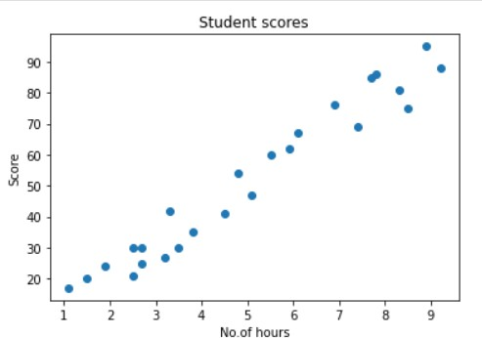

MCA 2020-22 20MCA241 DATA SCIENCE LAB

### #Perform the simple linear regression model #Equation: Y=w0+w1.x

**#Here Y(marks)=w0+w1.x #Create x as hours and Y as marks**

**INPUT**

X **=** student**.**iloc[:, :**-**1] y **=** student**.**iloc[:, 1] print(X)

**OUTPUT**

|  |  |
| --- | --- |
|  | Hours |
| 0 | 2.5 |
| 1 | 5.1 |
| 2 | 3.2 |
| 3 | 8.5 |
| 4 | 3.5 |
| 5 | 1.5 |
| 6 | 9.2 |
| 7 | 5.5 |
| 8 | 8.3 |
| 9 | 2.7 |
| 10 | 7.7 |
| ... |  |
| 24 | 7.8 |

**INPUT**

print(y)

MCA 2020-22 20MCA241 DATA SCIENCE LAB

**OUTPUT**

|  |  |  |
| --- | --- | --- |
| 0 | 21 |  |
| 1 | 47 |  |
| 2 | 27 |  |
| 3 | 75 |  |
| 4 | 30 |  |
| 5 | 20 |  |
| 6 | 88 |  |
| 7 | 60 |  |
| 8 | 81 |  |
| 9 | 25 |  |
| ... |  |  |
| 23 | 76 |  |
| 24 | 86 |  |
| Name:  **INPUT** | Scores, | dtype: int64 |

**from** sklearn.model_selection **import** train_test_split

X_train, X_test, y_train, y_test **=** train_test_split(X, y, test_size**=**0.2) print(X_train)

**OUTPUT**

|  |  |
| --- | --- |
|  | Hours |
| 24 | 7.8 |
| 5 | 1.5 |
| 21 | 4.8 |
| 15 | 8.9 |

MCA 2020-22 20MCA241 DATA SCIENCE LAB

|  |  |
| --- | --- |
| 20 | 2.7 |
| 9 | 2.7 |
| 10 | 7.7 |
| 6 | 9.2 |
| 12 | 4.5 |
| 1 | 5.1 |
| 14 | 1.1 |
| 3 | 8.5 |
| 0 | 2.5 |
| 13 | 3.3 |
| 8 | 8.3 |
| 4 | 3.5 |
| 23 | 6.9 |
| 17 | 1.9 |
| 7 | 5.5 |
| 16  **INPUT** | 2.5 |

**from** sklearn.linear_model **import** LinearRegression regressor **=** LinearRegression()

regressor**.**fit(X_train, y_train)

**OUTPUT**

LinearRegression()

**INPUT**

print(regressor**.**intercept_)

MCA 2020-22 20MCA241 DATA SCIENCE LAB

**OUTPUT**

3.3679146249897656

**INPUT**

print(regressor**.**coef_)

**OUTPUT**

[9.70315174]

**INPUT**

y_pred **=** regressor**.**predict(X_test)

**for**(i,j) **in** zip(y_test,y_pred):

**if** i**!=**j:

print("Actual value :",i,"Predicted value :",j)

print("Number of mislabeled points from test data set :", (y_test **!=** y_pred)**.**sum())

**OUTPUT**

Actual value : 62 Predicted value : 60.61650991569965 Actual value : 27 Predicted value : 34.41800020639174 Actual value : 67 Predicted value : 62.55714026453727 Actual value : 35 Predicted value : 40.239891252904606 Actual value : 69 Predicted value : 75.17123753198183 Number of mislabeled points from test data set : 5

MCA 2020-22 20MCA241 DATA SCIENCE LAB

**INPUT**

**from** sklearn **import** metrics

print("Mean Absolute error :", metrics**.**mean_absolute_error(y_test,y_pred)) print("Mean Squared error :", metrics**.**mean_squared_error(y_test,y_pred))

print("Root Mean Squared error :", np**.**sqrt(metrics**.**mean_squared_error(y_test,y_pred)))

**OUTPUT**

Mean Absolute error : 4.931095762208251 Mean Squared error : 28.444081504557726 Root Mean Squared error : 5.333299307610415

**INPUT**

**import** matplotlib.pyplot **as** plt c**=**X_test['Hours']**.**count() xax**=**np**.**arange(c)

print(xax)

X_axis **=** np**.**arange(len(xax))

plt**.**bar(X_axis**-**0.2, y_test, 0.6, label**=**'Actual') plt**.**bar(X_axis**+**0.2, y_pred, 0.6, label**=**'Predicted')

plt**.**xlabel("Test Records") plt**.**ylabel("Marks") plt**.**title("Student Score prediction") plt**.**legend()

plt**.**show()

MCA 2020-22 20MCA241 DATA SCIENCE LAB

**OUTPUT**

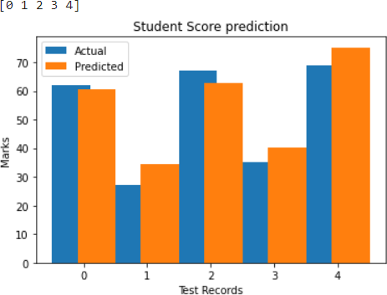

**INPUT**

## Multiple Linear Regression

**import** pandas **as** pd

**import** numpy **as** np

**import** matplotlib.pyplot **as** plt

advertising **=** pd**.**read_csv('Company_data.csv') advertising**.**head()

**OUTPUT**

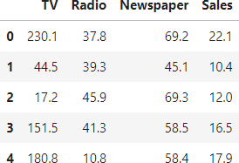

advertising**.**describe()

MCA 2020-22 20MCA241 DATA SCIENCE LAB

**OUTPUT**

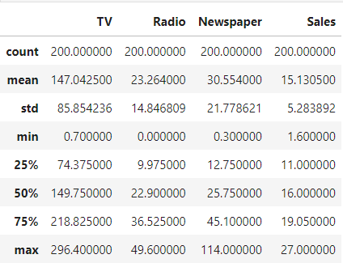

advertising**.**info()

**OUTPUT**

<class 'pandas.core.frame.DataFrame'> RangeIndex: 200 entries, 0 to 199 Data columns (total 4 columns):

# Column Non-Null Count Dtype

|  |  |  |  |  |
| --- | --- | --- | --- | --- |
| 0 | TV | 200 | non-null | float64 |
| 1 | Radio | 200 | non-null | float64 |
| 2 | Newspaper | 200 | non-null | float64 |
| 3 | Sales | 200 | non-null | float64 |

dtypes: float64(4) memory usage: 6.4 KB

MCA 2020-22 20MCA241 DATA SCIENCE LAB

**INPUT**

**import** matplotlib.pyplot **as** plt

**import** seaborn **as** sns

sns**.**pairplot(advertising, x_vars**=**['TV', 'Radio', 'Newspaper'], y_vars**=**'Sales', height**=**5, aspect**=**1, kind**=**'scatter')

plt**.**show()

**OUTPUT**

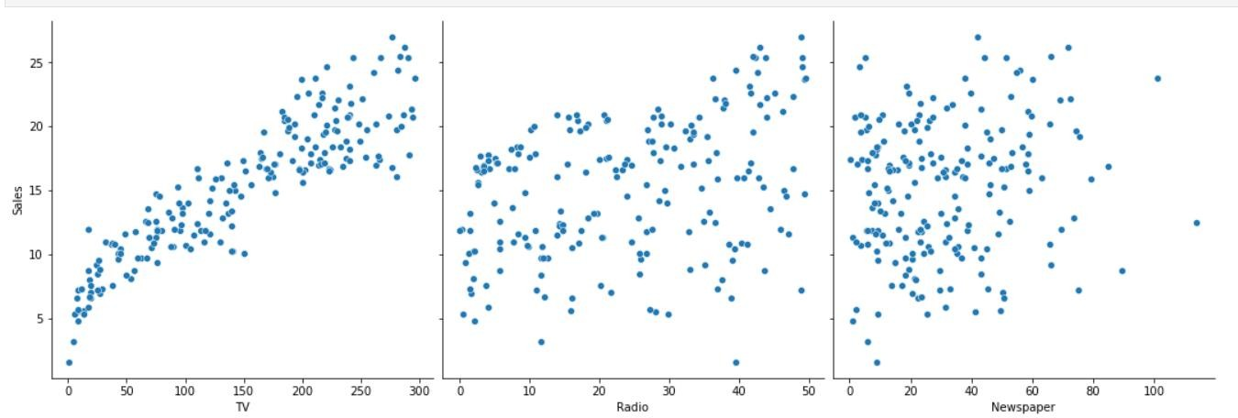

**INPUT**

#perform the multiple linear regression model #Equation : Y=w0+w1.x1 + w2.x2 + w3.x3

#Here Y(sales)=w0+w1.x1(TV)+w2.x2(Radio)+w3.x3(Newspaper) #create x and Y as sales

X **=** advertising**.**iloc[:, :**-**1] print(X)

MCA 2020-22 20MCA241 DATA SCIENCE LAB

**OUTPUT**

|  |  |  |  |
| --- | --- | --- | --- |
|  | TV | Radio | Newspaper |
| 0 | 230.1 | 37.8 | 69.2 |
| 1 | 44.5 | 39.3 | 45.1 |
| 2 | 17.2 | 45.9 | 69.3 |
| 3 | 151.5 | 41.3 | 58.5 |
| 4 | 180.8 | 10.8 | 58.4 |
| .. | ... | ... | ... |
| 195 | 38.2 | 3.7 | 13.8 |
| 196 | 94.2 | 4.9 | 8.1 |
| 197 | 177.0 | 9.3 | 6.4 |
| 198 | 283.6 | 42.0 | 66.2 |
| 199 | 232.1 | 8.6 | 8.7 |

[200 rows x 3 columns]

**INPUT**

y **=** advertising**.**iloc[:, **-**1] print(y)

**OUTPUT**

|  |  |
| --- | --- |
| 0 | 22.1 |
| 1 | 10.4 |
| 2 | 12.0 |
| 3 | 16.5 |
| 4 | 17.9 |
|  | ... |
| 195 | 7.6 |
| 196 | 14.0 |
| 197 | 14.8 |

MCA 2020-22 20MCA241 DATA SCIENCE LAB

198 25.5

199 18.4

Name: Sales, Length: 200, dtype: float64

**INPUT**

**from** sklearn.model_selection **import** train_test_split

X_train, X_test, y_train, y_test **=** train_test_split(X, y, test_size**=**0.3) print(X_train)

**OUTPUT**

|  |  |  |  |
| --- | --- | --- | --- |
|  | TV | Radio | Newspaper |
| 190 | 39.5 | 41.1 | 5.8 |
| 161 | 85.7 | 35.8 | 49.3 |
| 37 | 74.7 | 49.4 | 45.7 |
| 87 | 110.7 | 40.6 | 63.2 |
| 97 | 184.9 | 21.0 | 22.0 |
| .. | ... | ... | ... |
| 119 | 19.4 | 16.0 | 22.3 |
| 175 | 276.9 | 48.9 | 41.8 |
| 126 | 7.8 | 38.9 | 50.6 |
| 86 | 76.3 | 27.5 | 16.0 |
| 73 | 129.4 | 5.7 | 31.3 |

[140 rows x 3 columns]

**INPUT**

**from** sklearn.linear_model **import** LinearRegression regressor **=** LinearRegression()

regressor**.**fit(X_train, y_train)

MCA 2020-22 20MCA241 DATA SCIENCE LAB

**OUTPUT**

LinearRegression()

print(regressor**.**intercept_)

**OUTPUT**

4.479303977475622

print(regressor.coef_)

**OUTPUT**

[0.05389537 0.11490155 0.00179435]

**INPUT**

y_pred **=** regressor**.**predict(X_test)

**for**(i,j) **in** zip(y_test,y_pred):

**if** i**!=**j:

print("Actual value :",i,"Predicted value :",j)

print("Number of mislabeled points from test data set :", (y_test **!=** y_pred)**.**sum())

**OUTPUT**

Actual value : 11.5 Predicted value : 11.895846240525387 Actual value : 9.7 Predicted value : 9.317581242602184 Actual value : 19.4 Predicted value : 20.167393204252356 Actual value : 10.3 Predicted value : 12.275285815341341 Actual value : 18.2 Predicted value : 18.27397334414116

MCA 2020-22 20MCA241 DATA SCIENCE LAB

Actual value : 12.9 Predicted value : 13.753596405268244

...

Actual value : 7.6 Predicted value : 7.875678071895033 Actual value : 7.6 Predicted value : 6.988004625036124 Actual value : 25.4 Predicted value : 23.90563646791189 Number of mislabeled points from test data set : 60

**INPUT**

**from** sklearn **import** metrics

print("Mean Absolute error :", metrics**.**mean_absolute_error(y_test,y_pred)) print("Mean Squared error :", metrics**.**mean_squared_error(y_test,y_pred))

print("Root Mean Squared error :", np**.**sqrt(metrics**.**mean_squared_error(y_test,y_pred)))

**OUTPUT**

Mean Absolute error : 1.2379439849720684 Mean Squared error : 3.342870135490751

Root Mean Squared error : 1.8283517537636873

**INPUT**

**import** matplotlib.pyplot **as** plt c**=**X_test['TV']**.**count() xax**=**np**.**arange(c)

print(xax)

X_axis **=** np**.**arange(len(xax))

plt**.**bar(X_axis**-**0.2, y_test, 0.6, label**=**'Actual') plt**.**bar(X_axis**+**0.2, y_pred, 0.6, label**=**'Predicted')

plt**.**xlabel("Sales")

MCA 2020-22 20MCA241 DATA SCIENCE LAB

plt**.**ylabel("Actual/Predicted") plt**.**title("Sales prediction") plt**.**legend()

plt**.**show()

**OUTPUT**

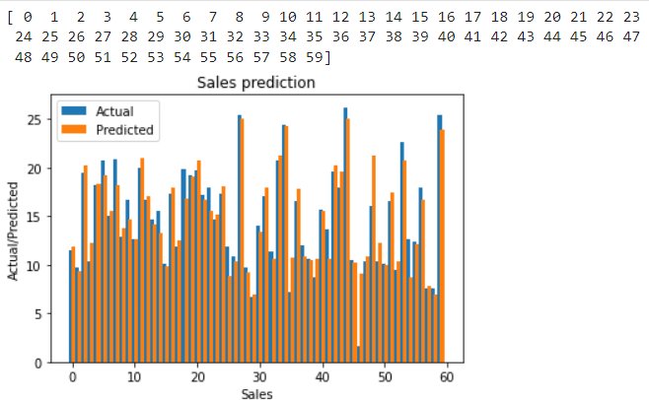

## Neural Networks

### #7. Create a neural network for the given ‘houseprice.csv’ to predict the whether price of the house is above or below median value or not.

**INPUT**

**import** tensorflow **as** tf

**import** keras **import** pandas **import** sklearn

MCA 2020-22 20MCA241 DATA SCIENCE LAB

**import** matplotlib

**OUTPUT**

2022-02-15 15:30:27.597560: W

tensorflow/stream_executor/platform/default/dso_loader.cc:64] Could not load dynamic library 'libcudart.so.11.0'; dlerror: libcudart.so.11.0: cannot open shared object file: No such file or directory

2022-02-15 15:30:27.597631: I

tensorflow/stream_executor/cuda/cudart_stub.cc:29] Ignore above cudart dlerror if you do not have a GPU set up on your machine.

**INPUT**

**import** pandas **as** pd

df **=** pd**.**read_csv('housepricedata.csv') df

**OUTPUT**

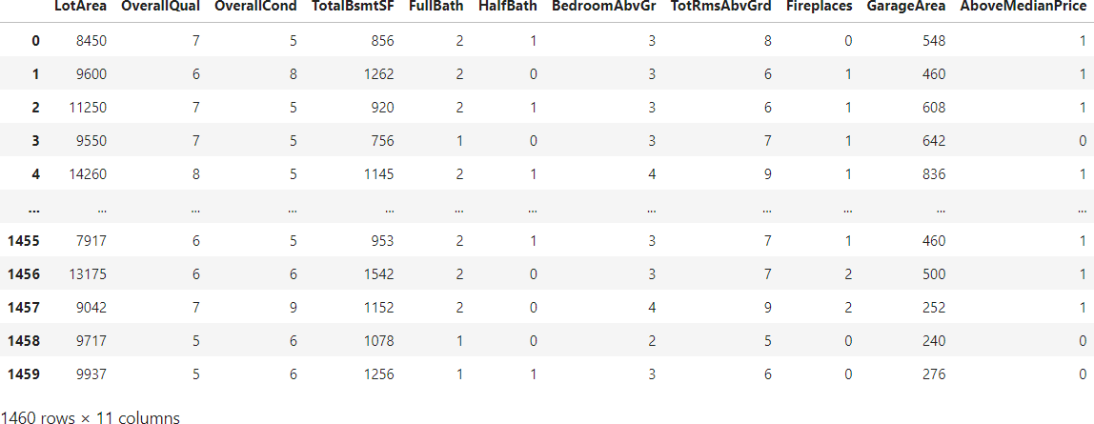

**INPUT**

|  |  |  |  |
| --- | --- | --- | --- |
| MCA 2020-22 |  | 20MCA241 DATA SCIENCE LAB | |
| dataset **=** df**.**values |  |  |  |
| dataset |  |  |  |
| **OUTPUT** |  |  |  |
| array([[ 8450, 7, 5, ..., | 0, | 548, | 1], |
| [ 9600, 6, 8, ..., | 1, | 460, | 1], |
| [11250, 7, 5, ..., | 1, | 608, | 1], |
| ..., |  |  |  |
| [ 9042, 7, 9, ..., | 2, | 252, | 1], |
| [ 9717, 5, 6, ..., | 0, | 240, | 0], |
| [ 9937, 5, 6, ..., | 0, | 276, | 0]]) |
| **INPUT** |  |  |  |
| X = dataset[:,0:10] |  |  |  |
| Y = dataset[:,10] |  |  |  |
| from sklearn import preprocessing |  |  |  |
| min_max_scaler = preprocessing.MinMaxScaler() |  |  |  |
| X_scale = min_max_scaler.fit_transform(X) |  |  |  |
| X_scale |  |  |  |

MCA 2020-22 20MCA241 DATA SCIENCE LAB

**OUTPUT**

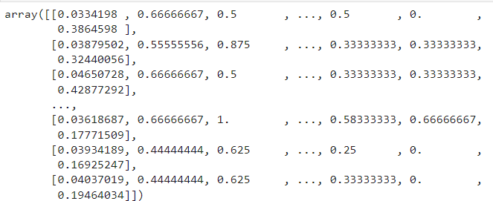

**INPUT**

**from** sklearn.model_selection **import** train_test_split

X_train, X_val_and_test, Y_train, Y_val_and_test **=** train_test_split(X_scale, Y, test_size**=**0.3)

X_val, X_test, Y_val, Y_test **=** train_test_split(X_val_and_test, Y_val_and_test, test_size**=**0.5)

print(X_train**.**shape, X_val**.**shape, X_test**.**shape, Y_train**.**shape, Y_val**.**shape, Y_test**.**shape)

**OUTPUT**

(1022, 10) (219, 10) (219, 10) (1022,) (219,) (219,)

**INPUT**

**from** keras.models **import** Sequential

**from** keras.layers **import** Dense

model **=** Sequential([

Dense(32, activation**=**'relu', input_shape**=**(10,)), Dense(32, activation**=**'relu'),

MCA 2020-22 20MCA241 DATA SCIENCE LAB

Dense(1, activation**=**'sigmoid'),

])

model**.**compile(optimizer**=**'sgd', loss**=**'binary_crossentropy', metrics**=**['accuracy'])

hist **=** model**.**fit(X_train, Y_train, batch_size**=**32, epochs**=**100, validation_data**=**(X_val, Y_val))

**OUTPUT**

2022-02-15 15:32:11.492039: W

tensorflow/stream_executor/platform/default/dso_loader.cc:64] Could not load dynamic library 'libcuda.so.1'; dlerror: libcuda.so.1: cannot open shared object file: No such file or directory

2022-02-15 15:32:11.492109: W

tensorflow/stream_executor/cuda/cuda_driver.cc:269] failed call to cuInit: UNKNOWN ERROR (303)

2022-02-15 15:32:11.492153: I

tensorflow/stream_executor/cuda/cuda_diagnostics.cc:156] kernel driver does not appear to be running on this host (Z238-UL):

/proc/driver/nvidia/version does not exist

2022-02-15 15:32:11.518227: I

tensorflow/core/platform/cpu_feature_guard.cc:151] This TensorFlow binary is optimized with oneAPI Deep Neural Network Library (oneDNN) to use the following CPU instructions in performance- critical operations: AVX2 FMA

To enable them in other operations, rebuild TensorFlow with the appropriate compiler flags.

Epoch 1/100

32/32 [==============================] - 1s 5ms/step - loss:

0.6723 - accuracy: 0.5059 - val_loss: 0.6751 - val_accuracy:

0.4886

MCA 2020-22 20MCA241 DATA SCIENCE LAB

Epoch 2/100

32/32 [==============================] - 0s 2ms/step - loss:

0.6648 - accuracy: 0.5039 - val_loss: 0.6690 - val_accuracy:

0.4886

Epoch 3/100

32/32 [==============================] - 0s 2ms/step - loss:

0.6578 - accuracy: 0.5098 - val_loss: 0.6634 - val_accuracy:

0.5662

...

Epoch 100/100

32/32 [==============================] - 0s 2ms/step - loss:

0.2789 - accuracy: 0.8885 - val_loss: 0.3786 - val_accuracy:

0.8584

**INPUT**

model**.**evaluate(X_test, Y_test)[1]

**OUTPUT**

7/7 [==============================] - 0s 1ms/step - loss: 0.2081

- accuracy: 0.9224

0.922374427318573

**INPUT**

**import** matplotlib.pyplot **as** plt

plt**.**plot(hist**.**history['loss']) plt**.**plot(hist**.**history['val_loss']) plt**.**title('Model loss') plt**.**ylabel('Loss') plt**.**xlabel('Epoch')

MCA 2020-22 20MCA241 DATA SCIENCE LAB

plt**.**legend(['Train', 'Val'], loc**=**'upper right') plt**.**show()

**OUTPUT**

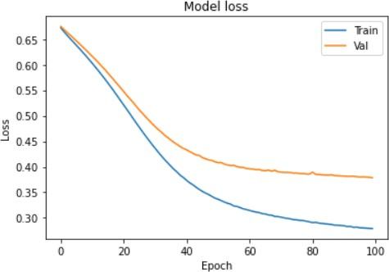

**INPUT**

plt**.**plot(hist**.**history['accuracy']) plt**.**plot(hist**.**history['val_accuracy']) plt**.**title('Model accuracy') plt**.**ylabel('Accuracy') plt**.**xlabel('Epoch')

plt**.**legend(['Train', 'Val'], loc**=**'lower right') plt**.**show()

MCA 2020-22 20MCA241 DATA SCIENCE LAB

**OUTPUT**

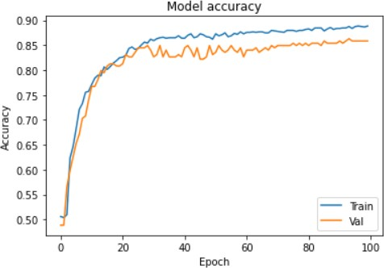

**INPUT**

model_2 **=** Sequential([

Dense(1000, activation**=**'relu', input_shape**=**(10,)), Dense(1000, activation**=**'relu'),

Dense(1000, activation**=**'relu'), Dense(1000, activation**=**'relu'), Dense(1, activation**=**'sigmoid'),

])

model_2**.**compile(optimizer**=**'adam', loss**=**'binary_crossentropy', metrics**=**['accuracy'])

hist_2 **=** model_2**.**fit(X_train, Y_train, batch_size**=**32, epochs**=**100, validation_data**=**(X_val, Y_val))

**OUTPUT**

MCA 2020-22 20MCA241 DATA SCIENCE LAB

Epoch 1/100

32/32 [==============================] - 1s 23ms/step - loss:

0.4627 - accuracy: 0.7759 - val_loss: 0.4173 - val_accuracy:

0.8311

Epoch 2/100

32/32 [==============================] - 1s 17ms/step - loss:

0.3340 - accuracy: 0.8552 - val_loss: 0.3791 - val_accuracy:

0.8858

Epoch 3/100

32/32 [==============================] - 1s 16ms/step - loss:

0.3195 - accuracy: 0.8679 - val_loss: 0.3670 - val_accuracy:

0.8767

...

Epoch 100/100

32/32 [==============================] - 0s 15ms/step - loss:

0.1051 - accuracy: 0.9589 - val_loss: 0.9088 - val_accuracy:

0.8904

**INPUT**

plt**.**plot(hist_2**.**history['loss']) plt**.**plot(hist_2**.**history['val_loss']) plt**.**title('Model loss') plt**.**ylabel('Loss') plt**.**xlabel('Epoch')

plt**.**legend(['Train', 'Val'], loc**=**'upper right') plt**.**show()

MCA 2020-22 20MCA241 DATA SCIENCE LAB

**OUTPUT**

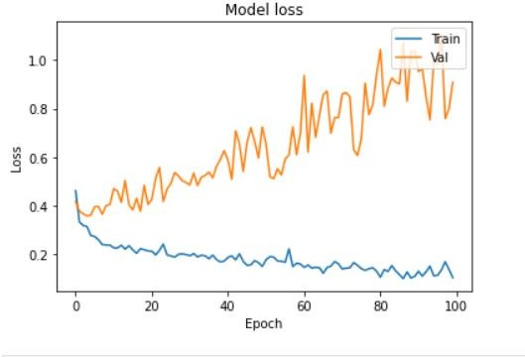

**INPUT**

plt**.**plot(hist_2**.**history['accuracy']) plt**.**plot(hist_2**.**history['val_accuracy']) plt**.**title('Model accuracy') plt**.**ylabel('Accuracy') plt**.**xlabel('Epoch')

plt**.**legend(['Train', 'Val'], loc**=**'lower right') plt**.**show()

MCA 2020-22 20MCA241 DATA SCIENCE LAB

**OUTPUT**

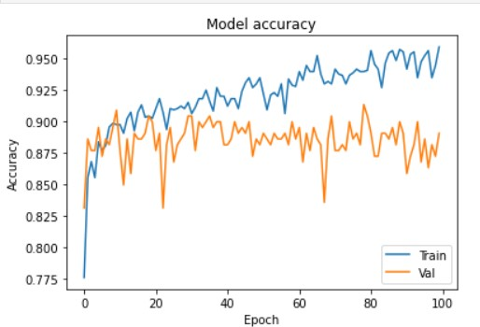

**INPUT**

**from** keras.layers **import** Dropout

**from** keras **import** regularizers

model_3 **=** Sequential([

Dense(1000, activation**=**'relu', kernel_regularizer**=**regularizers**.**l2(0.01), input_shape**=**(10,)),

Dropout(0.3),

Dense(1000, activation**=**'relu', kernel_regularizer**=**regularizers**.**l2(0.01)), Dropout(0.3),

Dense(1000, activation**=**'relu', kernel_regularizer**=**regularizers**.**l2(0.01)), Dropout(0.3),

Dense(1000, activation**=**'relu', kernel_regularizer**=**regularizers**.**l2(0.01)), Dropout(0.3),

Dense(1, activation**=**'sigmoid', kernel_regularizer**=**regularizers**.**l2(0.01)),

])

MCA 2020-22 20MCA241 DATA SCIENCE LAB

model_3**.**compile(optimizer**=**'adam', loss**=**'binary_crossentropy', metrics**=**['accuracy'])

hist_3 **=** model_3**.**fit(X_train, Y_train, batch_size**=**32, epochs**=**100, validation_data**=**(X_val, Y_val))

**OUTPUT**

Epoch 1/100

32/32 [==============================] - 1s 28ms/step - loss:

14.2275 - accuracy: 0.5930 - val_loss: 3.9129 - val_accuracy:

0.7260

Epoch 2/100

32/32 [==============================] - 1s 24ms/step - loss:

1.6881 - accuracy: 0.8102 - val_loss: 0.7029 - val_accuracy:

0.8584

Epoch 3/100

32/32 [==============================] - 1s 24ms/step - loss:

0.5424 - accuracy: 0.8640 - val_loss: 0.5901 - val_accuracy:

0.8402

...

Epoch 100/100

32/32 [==============================] - 1s 27ms/step - loss:

0.4391 - accuracy: 0.8777 - val_loss: 0.4947 - val_accuracy:

0.8630

**INPUT**

plt**.**plot(hist_3**.**history['loss']) plt**.**plot(hist_3**.**history['val_loss']) plt**.**title('Model loss') plt**.**ylabel('Loss')

MCA 2020-22 20MCA241 DATA SCIENCE LAB

plt**.**xlabel('Epoch')

plt**.**legend(['Train', 'Val'], loc**=**'upper right') plt**.**ylim(top**=**1.2, bottom**=**0)

plt**.**show()

**OUTPUT**

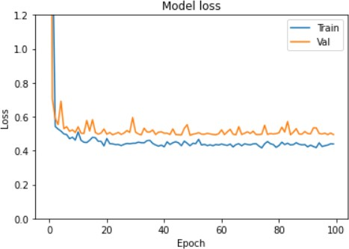

**INPUT**

plt**.**plot(hist_3**.**history['accuracy']) plt**.**plot(hist_3**.**history['val_accuracy']) plt**.**title('Model accuracy') plt**.**ylabel('Accuracy') plt**.**xlabel('Epoch')

plt**.**legend(['Train', 'Val'], loc**=**'lower right') plt**.**show()

MCA 2020-22 20MCA241 DATA SCIENCE LAB

**OUTPUT**

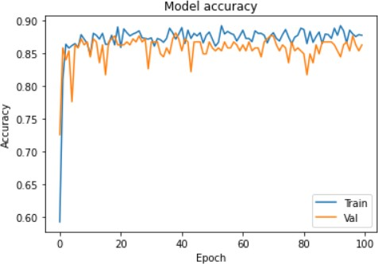

MCA 2020-22 20MCA241 DATA SCIENCE LAB

# LAB CYCLE-5

**SVM Classification**

**Given a data set of support tickets. Each ticket also has an associated "urgency score" of between 0 and 3, and where 0 is "very urgent" and 3 is "not urgent".It would be useful if we could have a machine guess how urgent a ticket is, based on the description, so the urgent tickets can be resolved first**

### #1. For the given data set, perform text classification using SVM and find out the accuracy of the model.

**INPUT**

**from** sklearn.feature_extraction.text **import** TfidfVectorizer, CountVectorizer

**from** sklearn.metrics **import** confusion_matrix

**from** sklearn.metrics **import** classification_report

**from** sklearn.model_selection **import** cross_val_score **from** sklearn.model_selection **import** cross_val_predict **from** sklearn.model_selection **import** train_test_split

**from** sklearn.svm **import** LinearSVC

**from** sklearn.tree **import** DecisionTreeClassifier

**from** sklearn **import** tree

**with** open("tickets.txt") **as** f:

tickets **=** f**.**read()**.**strip()**.**split("\n")

MCA 2020-22 20MCA241 DATA SCIENCE LAB

**with** open("labels_4.txt") **as** f: labels **=** f**.**read()**.**strip()**.**split("\n")

X_train, X_test, y_train, y_test **=** train_test_split(tickets, labels, test_size**=**0.1, random_state**=**1337)

vectorizer **=** CountVectorizer() svm **=** LinearSVC()

X_train **=** vectorizer**.**fit_transform(X_train) X_test **=** vectorizer**.**transform(X_test)

_ **=** svm**.**fit(X_train, y_train) y_pred **=** svm**.**predict(X_test)

print(classification_report(y_test, y_pred))

|  |  |  |  |  |
| --- | --- | --- | --- | --- |
| **OUTPUT** |  | | | |
|  | precision | recall | f1-score | support |
| 0 | 0.75 | 0.79 | 0.77 | 159 |
| 1 | 0.53 | 0.52 | 0.52 | 147 |
| 2 | 0.56 | 0.55 | 0.55 | 154 |
| 3 | 0.96 | 0.95 | 0.95 | 140 |
| accuracy |  |  | 0.70 | 600 |
| macro avg | 0.70 | 0.70 | 0.70 | 600 |
| weighted avg | 0.70 | 0.70 | 0.70 | 600 |

/home/sjcet/anaconda3/lib/python3.9/site- packages/sklearn/svm/_base.py:985: ConvergenceWarning: Liblinear failed to converge, increase the number of iterations.

|  |  |  |  |
| --- | --- | --- | --- |
| MCA 2020-22 | 20MCA241 DATA SCIENCE LAB | | |
| warnings.warn("Liblinear failed to converge, increase "  **INPUT**  print(confusion_matrix(y_test, y_pred))  **OUTPUT** | | | |
| [[126 | 18 | 14 | 1] |
| [ 20 | 76 | 49 | 2] |
| [ 19 | 48 | 84 | 3] |
| [ 3 | 1 | 3 | 133]] |

**K-means**

### #2. Given dataset contains 200 records and five columns, two of which describe the customer’s annual income and spending score. The latter is a value from 0 to 100. The higher the number, the more this customer has spent with the company in the past:

**Functions to familiarize:**

### The purpose of Kmeans.fit() is to train the model with data.

**The purpose of Kmeans.predict() is to apply a trained model to data.**

**INPUT**

**import** pandas **as** pd

customers **=** pd**.**read_csv('customer_data.csv') customers**.**head()

MCA 2020-22 20MCA241 DATA SCIENCE LAB

**OUTPUT**

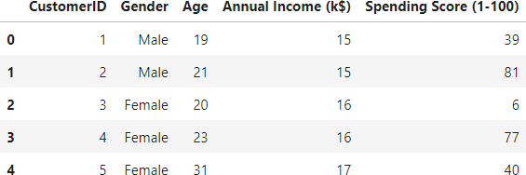

**INPUT**

**import** matplotlib.pyplot **as** plt points **=** customers**.**iloc[:, 3:5]**.**values x **=** points[:, 0]

y **=** points[:, 1]

plt**.**scatter(x, y, s**=**50, alpha**=**0.7) plt**.**xlabel('Annual Income (k$)') plt**.**ylabel('Spending Score') **OUTPUT**

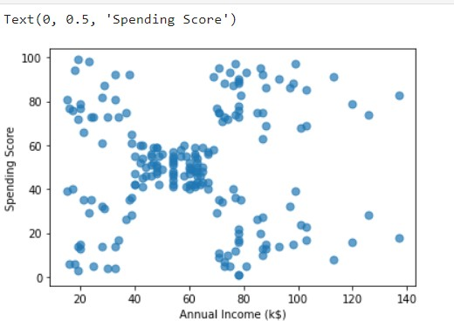

MCA 2020-22 20MCA241 DATA SCIENCE LAB

### #Q. Using k means clustering create 6 clusters of customers based on their spending pattern.Visualize the same in a scatter plot with each cluster in a different color scheme.

**INPUT**

**from** sklearn.cluster **import** KMeans

kmeans **=** KMeans(n_clusters**=**6, random_state**=**0) kmeans**.**fit(points)

predicted_cluster_indexes **=** kmeans**.**predict(points)

plt**.**scatter(x, y, c**=**predicted_cluster_indexes, s**=**50, alpha**=**0.7, cmap**=**'viridis') centers **=** kmeans**.**cluster_centers_

plt**.**scatter(centers[:, 0], centers[:, 1], c**=**'red', s**=**100)

**OUTPUT**

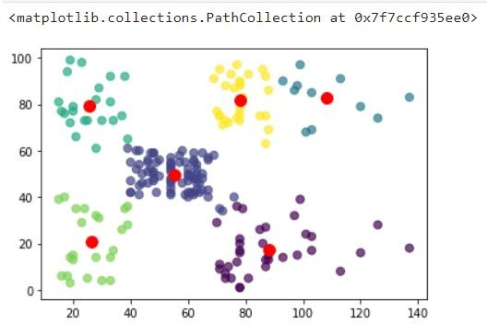

**#Display the cluster centers.**

**INPUT**

MCA 2020-22 20MCA241 DATA SCIENCE LAB

centers **=** kmeans**.**cluster_centers_

plt**.**scatter(centers[:, 0], centers[:, 1], c**=**'orange', s**=**100)

**OUTPUT**

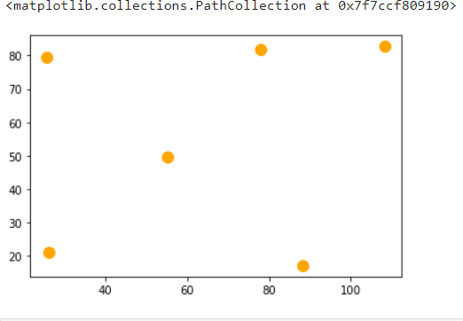

**#Use different values of K and visualize the same using scatter plot.**

**INPUT**

**from** sklearn.cluster **import** KMeans

kmeans **=** KMeans(n_clusters**=**7, random_state**=**0) kmeans**.**fit(points)

predicted_cluster_indexes **=** kmeans**.**predict(points)

plt**.**scatter(x, y, c**=**predicted_cluster_indexes, s**=**50, alpha**=**0.7, cmap**=**'viridis') centers **=** kmeans**.**cluster_centers_

plt**.**scatter(centers[:, 0], centers[:, 1], c**=**'red', s**=**100)

MCA 2020-22 20MCA241 DATA SCIENCE LAB

**OUTPUT**

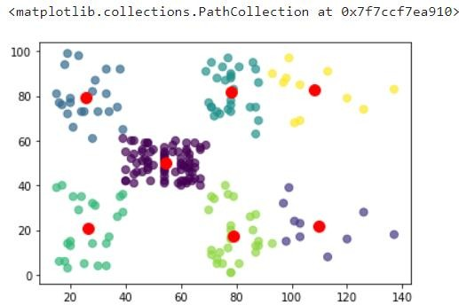

**#Use different values of K and visualize the same using scatter plot. INPUT**

**from** sklearn.cluster **import** KMeans

kmeans **=** KMeans(n_clusters**=**8, random_state**=**0) kmeans**.**fit(points)

predicted_cluster_indexes **=** kmeans**.**predict(points)

plt**.**scatter(x, y, c**=**predicted_cluster_indexes, s**=**50, alpha**=**0.7, cmap**=**'viridis') centers **=** kmeans**.**cluster_centers_

plt**.**scatter(centers[:, 0], centers[:, 1], c**=**'red', s**=**100)

MCA 2020-22 20MCA241 DATA SCIENCE LAB

**OUTPUT**

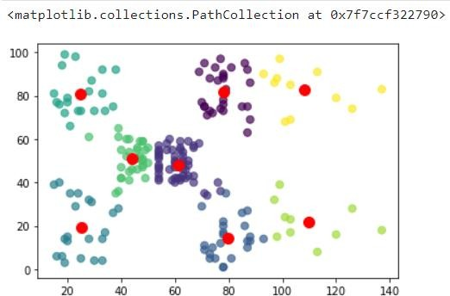

**#Display the cluster labels of each point.(print cluster indexes)**

**INPUT**

print(predicted_cluster_indexes)

**OUTPUT**

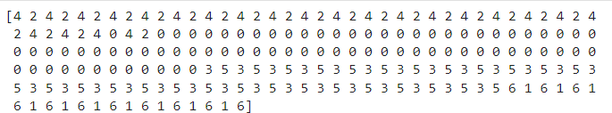

MCA 2020-22 20MCA241 DATA SCIENCE LAB

**NLP**

**#3. For given text, perform word and sentence tokenization.Remove the stop words from the given text and create n-grams for different values of n.**

**INPUT**

**from** nltk.corpus **import** stopwords

**import** nltk

**from** nltk.tokenize **import** sent_tokenize,word_tokenize

text1 **=** "The data set given satisfies the requirement for model generation. This is used in Data Science Lab"

print(sent_tokenize(text1))

['The data set given satisfies the requirement for model generation.', 'This is used in Data Science Lab']

print(word_tokenize(text1))

**OUTPUT**

['The', 'data', 'set', 'given', 'satisfies', 'the', 'requirement',

'for', 'model', 'generation', '.', 'This', 'is', 'used', 'in', 'Data', 'Science', 'Lab']

**INPUT**

print(stopwords**.**words('english'))

**OUTPUT**

['i', 'me', 'my', 'myself', 'we', 'our', 'ours', 'ourselves',

'you', "you're", "you've", "you'll", "you'd", 'your', 'yours',

MCA 2020-22 20MCA241 DATA SCIENCE LAB

'yourself', 'yourselves', 'he', 'him', 'his', 'himself', 'she',

"she's", 'her', 'hers', 'herself', 'it', "it's", 'its', 'itself',

'they', 'them', 'their', 'theirs', 'themselves', 'what', 'which',

'who', 'whom', 'this', 'that', "that'll", 'these', 'those', 'am',

'is', 'are', 'was', 'were', 'be', 'been', 'being', 'have', 'has',

'had', 'having', 'do', 'does', 'did', 'doing', 'a', 'an', 'the',

'and', 'but', 'if', 'or', 'because', 'as', 'until', 'while', 'of',

'at', 'by', 'for', 'with', 'about', 'against', 'between', 'into',

'through', 'during', 'before', 'after', 'above', 'below', 'to',

'from', 'up', 'down', 'in', 'out', 'on', 'off', 'over', 'under',

'again', 'further', 'then', 'once', 'here', 'there', 'when',

'where', 'why', 'how', 'all', 'any', 'both', 'each', 'few',

'more', 'most', 'other', 'some', 'such', 'no', 'nor', 'not',

'only', 'own', 'same', 'so', 'than', 'too', 'very', 's', 't',

'can', 'will', 'just', 'don', "don't", 'should', "should've",

'now', 'd', 'll', 'm', 'o', 're', 've', 'y', 'ain', 'aren', "aren't", 'couldn', "couldn't", 'didn', "didn't", 'doesn',

"doesn't", 'hadn', "hadn't", 'hasn', "hasn't", 'haven', "haven't",

'isn', "isn't", 'ma', 'mightn', "mightn't", 'mustn', "mustn't",

'needn', "needn't", 'shan', "shan't", 'shouldn', "shouldn't",

'wasn', "wasn't", 'weren', "weren't", 'won', "won't", 'wouldn', "wouldn't"]

**INPUT**

text **=** word_tokenize(text1)

text**=** [word **for** word **in** text **if** word **not in** stopwords**.**words('english')] print(text)

**OUTPUT**

['The', 'data', 'set', 'given', 'satisfies', 'requirement',

'model', 'generation', '.', 'This', 'used', 'Data', 'Science', 'Lab']

print(nltk**.**pos_tag(text))

MCA 2020-22 20MCA241 DATA SCIENCE LAB

**OUTPUT**

[('The', 'DT'), ('data', 'NN'), ('set', 'NN'), ('given', 'VBN'),

('satisfies', 'NNS'), ('requirement', 'VBP'), ('model', 'NN'),

('generation', 'NN'), ('.', '.'), ('This', 'DT'), ('used', 'VBN'),

('Data', 'NNP'), ('Science', 'NNP'), ('Lab', 'NNP')]

**INPUT**

temp**=**zip(**\***[text[i:] **for** i **in** range(0,2)]) ans**=**[' '**.**join(ngram) **for** ngram **in** temp] print(ans)

**OUTPUT**

['The data', 'data set', 'set given', 'given satisfies', 'satisfies requirement', 'requirement model', 'model generation', 'generation .', '. This', 'This used', 'used Data', 'Data Science', 'Science Lab']

**INPUT**

temp**=**zip(**\***[text[i:] **for** i **in** range(0,4)]) ans**=**[' '**.**join(ngram) **for** ngram **in** temp] print(ans)

**OUTPUT**

['The data set given', 'data set given satisfies', 'set given satisfies requirement', 'given satisfies requirement model', 'satisfies requirement model generation', 'requirement model generation .', 'model generation . This', 'generation . This used', '. This used Data', 'This used Data Science', 'used Data Science Lab']